**INSTRUCTIONS FOR OFFICIAL ADMISSION REQUEST AND PAYMENT OF APPLICATION FEE**

# ACCESS LINK

[ENTER SYSTEM FOR ADMISSION](https://www4.uc.cl/POV/autenticacion/pov_autenticacion.jspx)

# INSTRUCTIONS

If you have not previously registered to this platform, you should start by registering where it says “SI INGRESA POR PRIMERA VEZ, REGÍSTRESE AQUÍ".

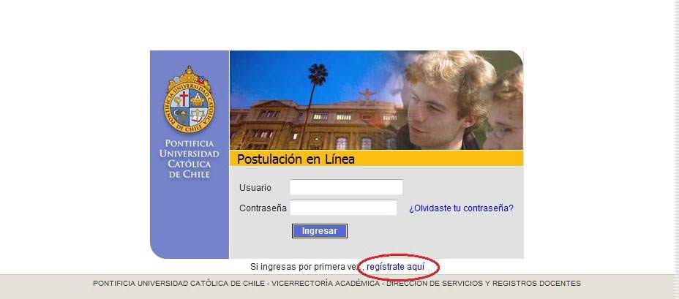

Write your Passport or ID number and then click on "ENTER", and the registration form will be displayed, with the following basic information:

• Names and surnames

• Email

• Birthdate

• Address

• Landline and mobile phone

You must create a username and password. You will need it every time you access the system.

Once this registration is complete, you will receive, by email, the confirmation to enter the system. The email you have indicated when registering will be the official way of communication and information (it is suggested to add the electronic address "admision@uc.cl" to your address list).

## Access to the System

Enter with the created password: username and password.

Complete the requested information. Fields marked with an asterisk (*) are required.

Upload your digital photograph (weight between 20 and 200 KB, plain background, white). This photo will be used for all your future activities with the University.





## Program Selection and admission route

Select the program to which you wish to apply, the admission route is "Postgrado"

Then you must pick either:

“Magíster en Ciencias de la Ingeniería” (Masters)

Or

“Doctorado en Ciencias de la Ingeniería” (Doctorate)

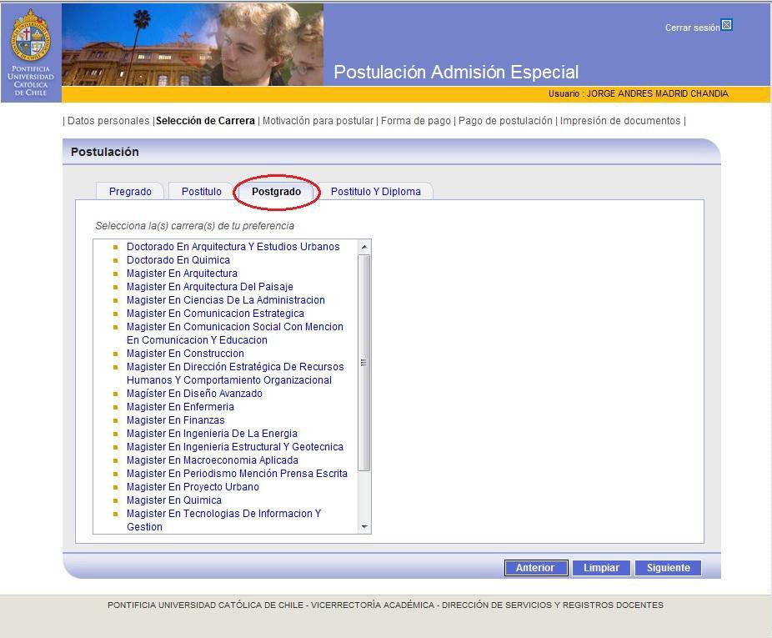

## Payment of Application Fee

The application fee is $ 57,000 * or US $ 103 * (Regular students of this University have a discount)

Payment can be made through Webpay with credit card (this system is recommended) or bank deposit. If you opt for a bank deposit, you must send an email to admision@uc.cl including a copy of the Proof of deposit, your full name, Passport or ID number and the program to which you apply.

This in order to be unlocked and can print requested forms.

People who choose Webpay can automatically access the forms.

* year values ​​2017

## Documents printing

The system allows you to download, save and print documentation that must be submitted when formalizing your application with the respective program. These are:

• Official Admission Request

• Proof of Payment of Application Fee (only Master Program)

• Accumulated Academic Record (only regular students or graduates of this University)

• Ranking Certificate ((only regular students or graduates of this University)